Pepper Money Limited

2024 Half Year Results Presentation

Script

Results: Thursday 29 August 2024

**slide number 2**

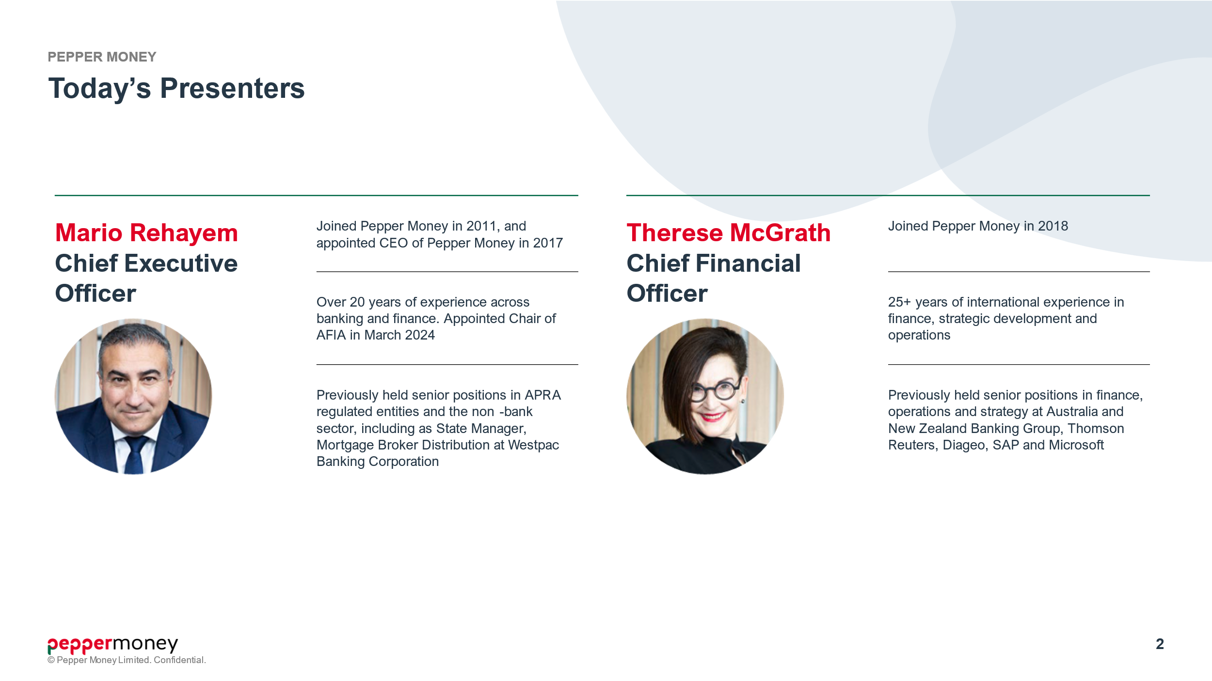

* Good morning, everyone and welcome to Pepper Money Limited’s 2024 half year results presentation. My name is Gordon Livingstone - Investor Relations at Pepper Money.
* I would like to begin by acknowledging the traditional custodians of the land on which we meet today, the Gadigal people of the Eora Nation. We pay our respects to each of their Elders, past, present, and emerging.
* Today, Pepper Money's CEO - Mario Rehayem - will provide a business update after which Pepper Money’s CFO - Therese McGrath - will take us through the financial performance. After some closing remarks by Mario - there will be an opportunity to ask questions, which can be either via phone, or submitted via the portal.
* I will now pass over to Pepper Money’s CEO – Mario Rehayem.

slide number 3

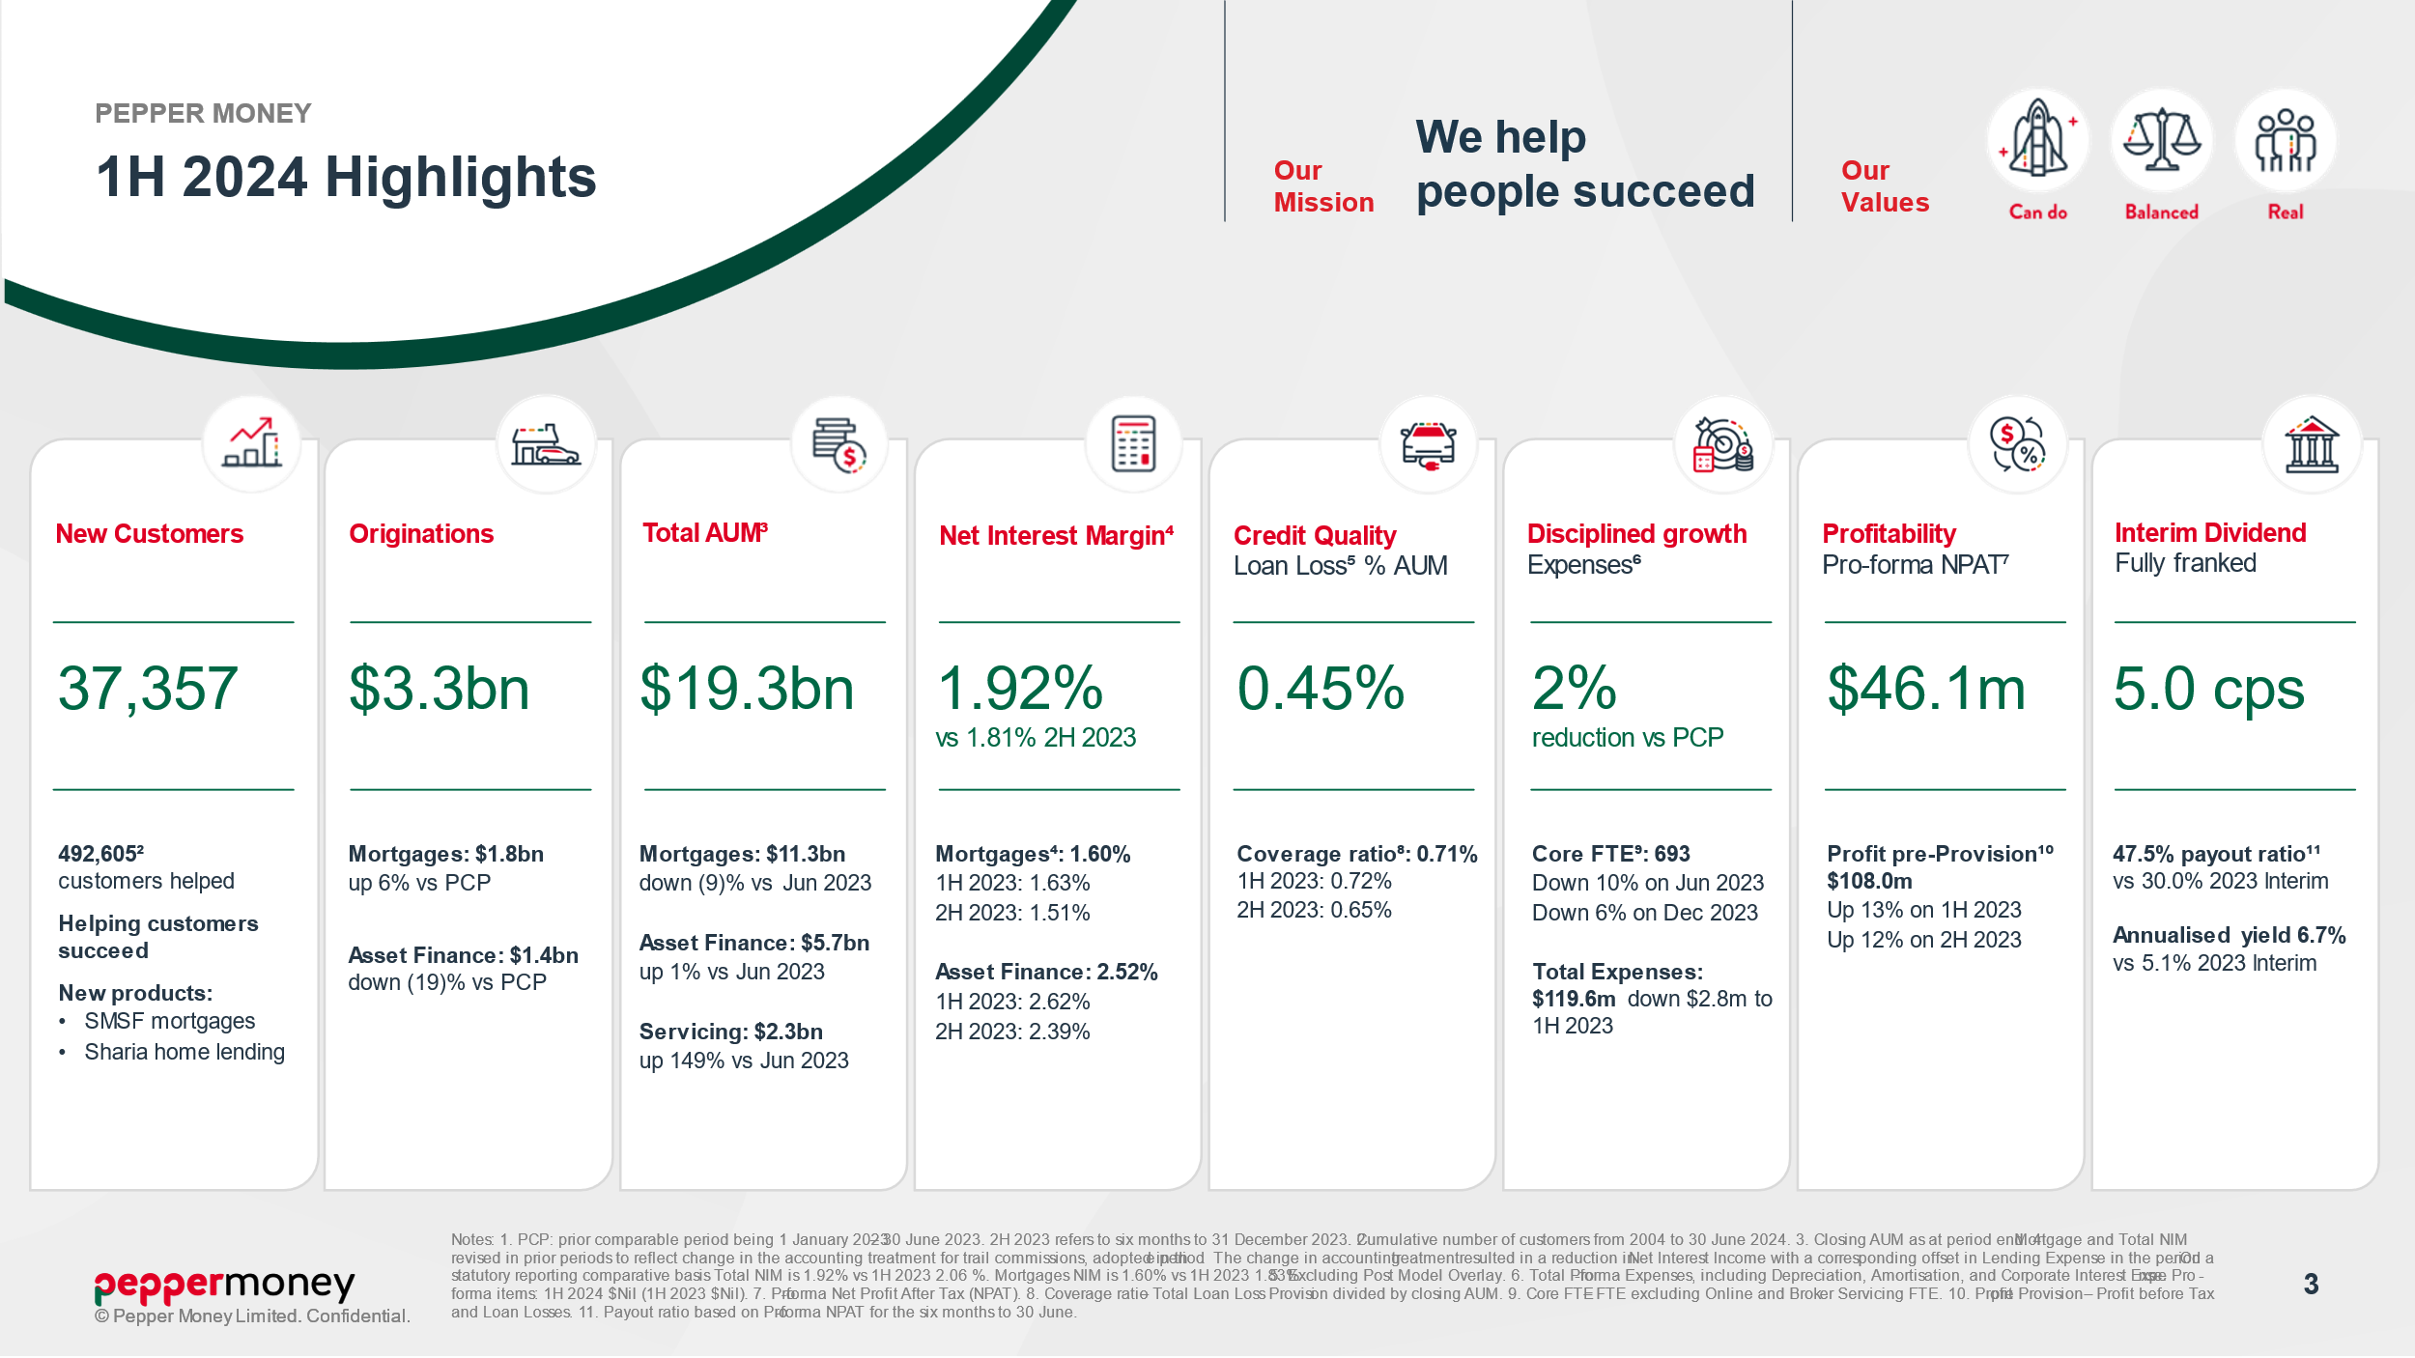

* Thank you, Gordon. And thank you to everyone that has dialled in today. I will start off with our first half 2024 highlights located on page 3 of the Investor Presentation.
* We have started 2024 strongly:
  + Mortgage volumes are up;
  + NIM has increased versus the second half of 2023;
  + and expenses are down.
* It is the consistent application of our strategy that has seen the business continue to successfully navigate the cycle. Our results for the first half of 2024 reflect our ability to respond to market conditions, deliver on customer needs, and leverage our diversified business portfolio.
* We delivered Originations of $3.3 billion over the first half of 2024.
  + Mortgage Originations of $1.8 billion increased 6% on the prior comparable period. Market conditions started to show signs of stability over the latter part of 2023 and have held into 2024. I am encouraged by this trend.
  + Asset Finance performed well over the first half, delivering Originations of $1.4 billion. While Originations were down 19% on PCP, this was due in part to soft market conditions, and ongoing cost of living pressure suppressing demand, as well as the first half of 2023 benefiting from strong Commercial growth ahead of the removal of Government tax incentives on the first of July 2023.
* Customers are at the forefront of how we do business given our mission to “help people succeed” - and customer wellbeing forms part of this mission. We welcomed 37,357 new customers to Pepper Money over the first half of 2024. We also made sure we found ways to help our existing customers navigate increasingly difficult economic conditions. We continue to focus on providing all the right touch points to support our customers if and when needed. And in August 2024, we also hit one of our core strategic milestone – passing the mark of having helped over 500,000 customers since 2004
* Total AUM – which is a key foundation of future profitability – closed June 2024 at $19.3 billion.
* In line with our funding and capital management strategy, we undertook four Whole Loan Sales over the first half of 2024 totalling $1.1 billion – 2 in Prime Mortgages, one Non-Conforming and a further in Asset Finance.
* Funding margins continue to improve with PRS40, which settled on 16 August, pricing 36 basis points inside PRS39, 63 basis points better than PRS38 and 93 basis points better than PRS37.
* Lending AUM was $17.0 billion, Mortgages at $11.3 billion and Asset Finance at $5.7 billion. Servicing AUM increased by $1.4 billion over the prior comparable period to close June 2024 at $2.3 billion, reflecting the transfer of AUM from the Whole Loan Sales.
* Net Interest Margin is stabilising, following the wind back of intense competition amongst the banks that we saw over 2023, coupled with more stable swap rates and improved funding margins. NIM also benefited from our ability to balance our mix given our portfolio diversification. In response to changes in market practice we have changed how we account for Mortgages Trail Commission. Therese will cover the change in the financials. On a like for like basis Total NIM at 1.92% increased from 1.81% in the second half of 2023. Mortgage NIM at 1.60% was up 9 basis points over the second half of 2023 and Asset Finance NIM of 2.52% improved 13 basis points over the same period.
* Credit performance over the first half of 2024 saw our Loss ratio – being Loan Losses as a per cent of AUM - move to 0.45%. We remain well provisioned – we are holding $120.8 million in total provisions giving a Coverage ratio at 0.71%
* I have spoken in the past about how we have built a scaled technology platform, supporting automation. This, coupled with our disciplined approach to cost management, saw Expenses decrease by 2% versus first half of 2023, with Core FTEs reducing 10% over the same period.
* A real stand out is our Profit pre-Provisions – being profit before tax and loan losses – at $108 million was up 13% on prior comparable period. Pro-forma and Statutory NPAT for the first half 2024 was $46.1 million.
* In line with the change in our Dividend Policy announced in February, the Board has increased the pay-out ratio to 47.5%, and declared a fully franked Interim dividend of 5.0 cents per share on the Net Profit After Tax for the six months to 30 June 2024, up from 30.0% payout, and increase of 1.5 cents per share, versus the 2023 Interim dividend.
* Turning now to slide 4 – our Mortgage business performance.

slide number 4

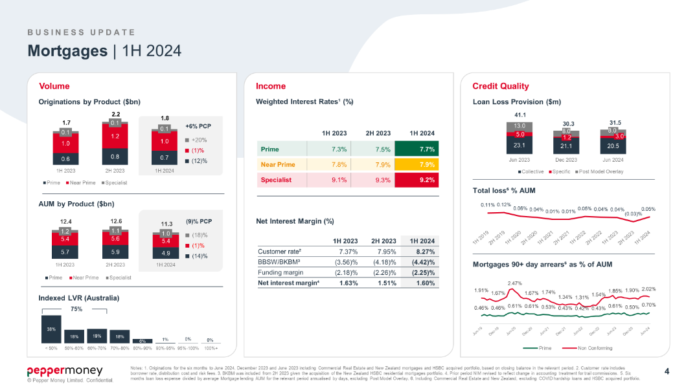

* Market conditions for Mortgages were generally soft, but there are clear signs of stabilisation. The intense competition across the entire sector seen over 2023 has reduced.
* As I discussed at the time of our full year results, our focus for Mortgages has been to leverage our position in the Non Conforming segment – an area banks do not play in - and to develop new products for those customer niches not best served by traditional banks.
* Mortgage Originations over the first half of 2024 grew by 6% on PCP, with the product mix skewed to Near Prime and Specialist, which accounted for 60% of our Mortgage Originations. Pepper Money started over 24 years ago as a Non Conforming lender and today we continue to have strong market position in this space.
* Mortgage volumes benefited from new products launched in Australia. Our Self Managed Super Fund Mortgage launched in October 2023 is performing well ahead of expectations as we focus on delivering a seemless process for brokers and customers alike.
* Over the first half of 2024 we executed three Mortgage Whole Loan Sales – two Prime and one Non Conforming. Whole Loan Sales have been a part of our funding and capital management strategy since 2016. Whole Loan Sales see the equitable notes sold to a third party, with Pepper Money retaining the Servicing of the loans. AUM therefore transfers from Lending to Servicing, and as Pepper Money retains the servicing of the loans, we benefit from the generation of a capital light annuity-style income.
* Mortgage Lending AUM dropped by (9)% on PCP to $11.3 billion.
* At our full year results I said that we expected to see Mortgage NIM stabilise, as both market conditions and customer attrition stabilised. This was certainly the case and NIM on a like for like basis for Mortgages increased 9 basis points on the second half of 2023 to 1.60%.
* The NIM walk and Credit performance will be covered in the Financials.
* Turning to Asset Finance.

slide number 5

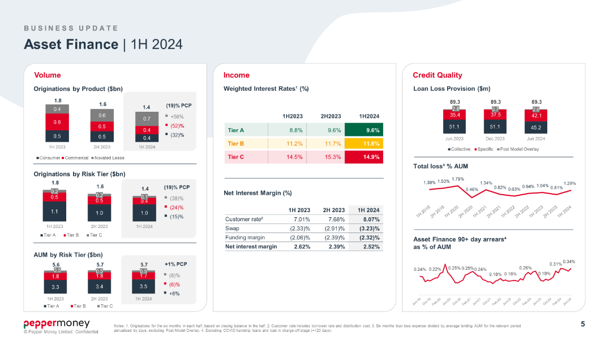

* Our Asset Finance business delivered solid results over the first six months of 2024, given tough market conditions, including:
  + consumer and business confidence being at historic lows as cost of living and rate rise concerns weighed heavily and slowed application and originations growth;
  + business insolvencies accelerated – with ASIC reporting a 36% increase over the fiscal year ending 30 June 2024.
* The first half of 2023 also had the benefit of higher Commercial Originations, as businesses sought to capitalise on tax incentives before they ceased on the 1st July 2023.
* In Asset Finance we delivered Originations of $1.4 billion, down 19% on prior comparable period – but only 8% down on the second half of 2023. Our Novated Lease business continued to grow well ahead of system – with Originations at $700 million up 56% on PCP.
* As part of our funding and capital management strategy we executed another Whole Loan Sale in Asset Finance in June 2024 of half a billion. Whole Loan Sales sees the AUM move from Lending to Servicing.
* After the Whole Loan Sale in June, AUM for Asset Finance closed the first half of 2024 at $5.7 billion – up 1% on PCP and in line with December 2023 close.
* Given both increasing insolvencies and cost of living pressures on consumer, we focused over the first half of 2024 on growing our Tier A customers - while being more conservative on Tier B and Tier C. Novated Lease customers are typically Tier A. In total Tier A customers accounted for 67% of Asset Finance Originations over the first half of 2024.
* Asset Finance Net Interest Margin at 2.52% compared to the second half of 2023 improved 13 basis points.
* While Therese will cover off Credit in detail in the Financials - overall, Asset Finance Loan Loss Provisions remains constant versus PCP, as the Whole Loan Sale in June released Collective Provisions. Total Loan Losses Provisions for first half 2024 closed at $89.3 million, which is in line with 2023-year end giving a constant Coverage ratio of 1.57%.
* Now to Loan and Other Servicing.

slide number 6

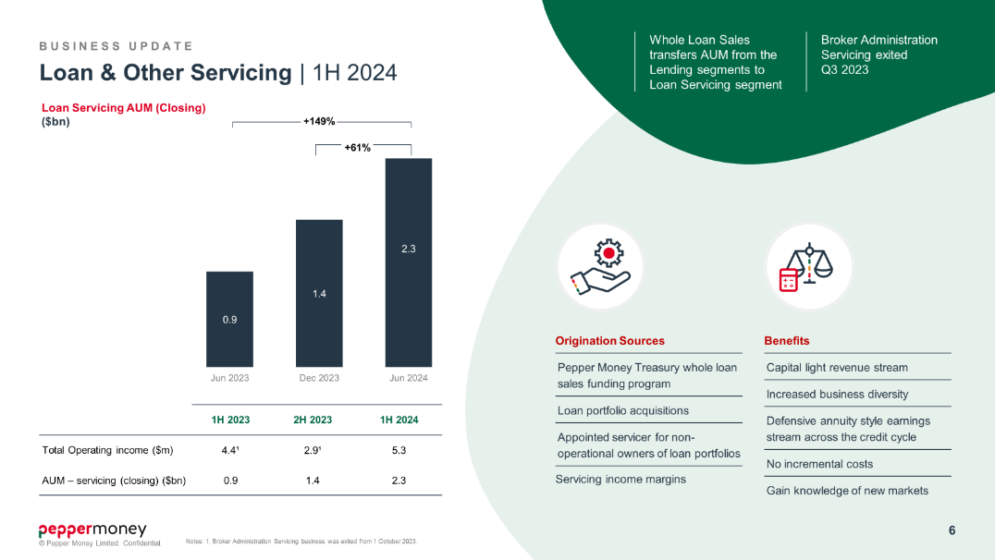

* Our Loan and Other Servicing business is the provision of independent loan servicing to the market, and includes:
* our Whole Loan Sales servicing program;
* servicing for non-operational owners of loan portfolios – for example our appointment as administrator of the Treasury Corporation of Victoria’s new commercial and industrial property tax;

and

* loan portfolio acquisition.

* Loan and Other Servicing grew over the first half of 2024 given the extension of our Whole Loan Sale strategy into Non-Conforming Mortgages as well as a further Whole Loan Sale in Asset Finance.
* Building our Loan and Other Servicing business, via Whole Loan Sales, is part of our overall capital management strategy, as:
* it is capital light. Whole Loan Sales allows us to recycle capital against growth opportunities;
* it provides an annuity style income, and no incremental cost to the business given the loans are already being serviced;

and

* it provides us with a defensive earnings stream across the credit cycle.
* Servicing AUM in the first half of 2024 increased to $2.3 billion up from $900 million in the prior comparable period. The increase in Servicing AUM supported Total Operating Income increasing to $5.3 million over the first half of 2024.
* Now turning to funding on slide 7.

slide number 7

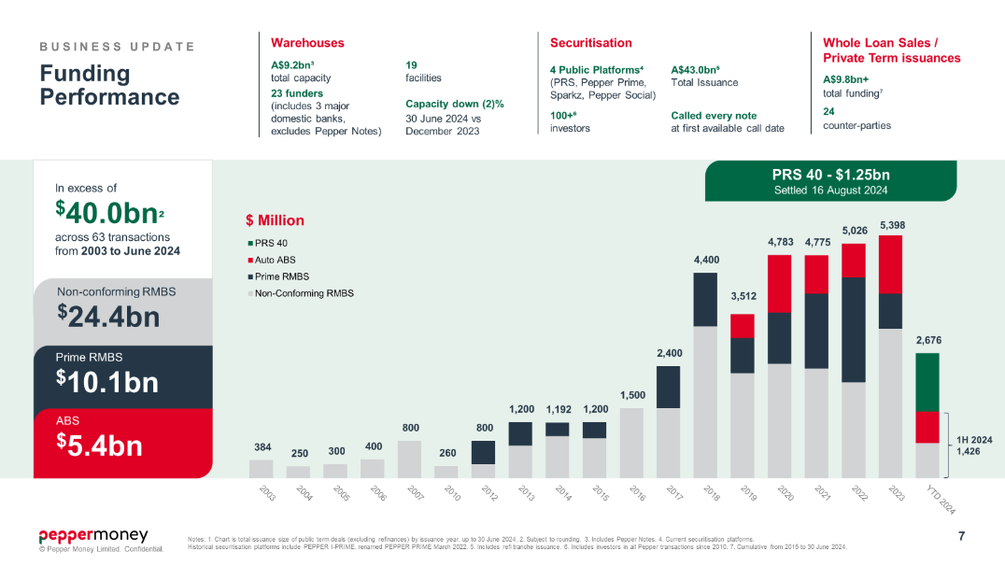

* Funding is a core strength of Pepper Money. We are a frequent and programmatic issuer with an unblemished 24-year history.
* As at the 30th of June 2024 our Warehouse Capacity stood at $9.2 billion.
* Over the first half of 2024, we completed two Public Term Securitisations – one RMBS and one ABS – raising in excess of $1.4 billion. We also raised a further $1.1 billion from Whole Loan Sales, and since close of the half year we also completed our 40th Non-Conforming Mortgage Public Securitisation – PRS 40 - which was our largest all Australian Dollar Securitisation in our history. What I am most pleased about was how strong the demand was – we were able to upsize to $1.25 billion. Likewise, the margin for PRS40 at 1.30% was 36 basis points better than PRS39 which completed in February 2024 and improved 63 basis points on PRS38 which completed in August 2023. I am very encouraged by how debt capital markets, and our funding activities, continue to improve.

* I will now hand over to Therese to run through the financials, after which I will make some closing comments before opening to questions.

slide number 8

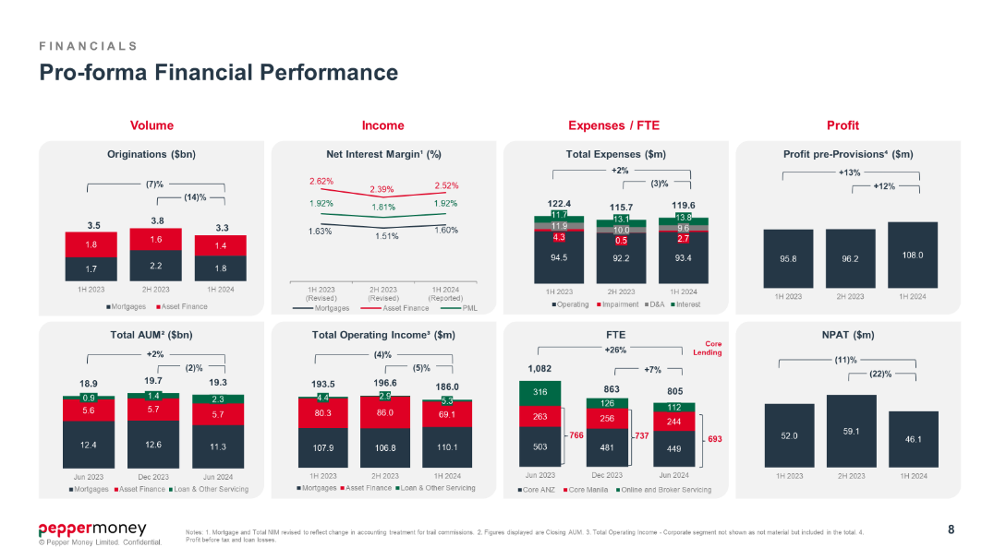

* Thank you, Mario, and good morning, everyone.
* As Mario has covered key volume trends, I will focus today on Net Interest Margin, Credit performance, Expense management and Capital.
* But before turning to NIM.
* In the first half of 2024 we changed our accounting treatment for Mortgages Trail Commission, to align with market practice, following a shift across the banking industry.
* Historically, we recognised trail commission liability and trail commission expense on a monthly accrual basis. This amount has been immaterial. The change in accounting treatment results in a financial asset and financial liability being booked that reflect an estimate of the Net Present Value of ongoing trail commission expense over the expected life of the underlying mortgage.
* We adopted the change effective 1 January 2024 for reporting at half-year. As the impact was deemed immaterial, prior periods have not been restated in the financial statements.
* One aspect of the adoption of the treatment has been a reduction in Net Interest Income of $(11.1) million with a corresponding offset in Lending Expense. Total Operating Income remains constant. For comparative purposes, in this presentation, Net Interest Margin has been revised across all periods to provide a like on like presentation.
* I have included in the Appendix a chart that breaks down the key drivers of Operating Income, and which illustrates the change in accounting presentation.
* So to turn to Net Interest Margin, on slide 9.

slide number 9

* As Mario has noted: Net Interest Margin is stabilising and has improved versus the second half of 2023.
* Total NIM for the first half of 2024 at 1.92 per cent was in line with PCP and grew 11 basis points over the second half of 2023. The improvement versus the second half was delivered by:
* the flow through of pricing initiatives, which drove a 34 basis points improvement in Customer Rates and;
* funding margins – which started to see an improvement in the second half of 2023 and supported a further 3 basis points improvement in Total NIM;

however

* these gains were partially offset by the flow through of prior period adverse swap rate spreads, which drove NIM down by (26) basis point.
* Mortgages Net Interest Margin, at 1.6% improved 9 basis points on the second half of 2023:
* back and front book price increases implemented across our Mortgages portfolio, in response to when the RBA increased interest rates, flowed through as OCR stabilised. This resulted in underlying Customer Rates improving by 31 basis points versus the second half of 2023.
* Mortgage NIM also saw the benefit from improved funding margins, which Mario has already covered.
* These gains were partially offset as the prior period adverse movement in BBSW flowed through reducing NIM by (24) basis points.
* Our Asset Finance business – which is the graph on the lower right-hand side – also saw NIM increased versus the second half of 2023, in much the same way as Mortgages:
  + the volatility in swap rates experienced through 2023 eroded NIM by (32) basis points.

however

* + Like Mortgages – customers and partners come to our Asset Finance business given our service levels, speed to yes and ease of doing business. Pricing initiatives saw our average Customer Rates increase 39 basis points, net of mix, versus the second half of 2023.
* Now turning to slide 10 – Credit performance.

slide number 10

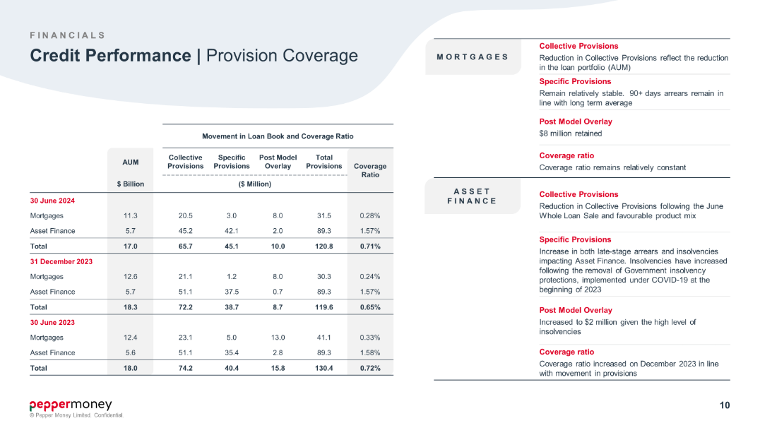

* The economic environment, and cost of living pressures, have proved challenging for a number of our customers. While most customers, particularly in Mortgages, are managing, not unexpectedly we have experienced some deterioration in credit quality over the first half of 2024.
* Most notably we have seen a heightened number of insolvencies in Australia as well as an increase in late-stage arrears, both of which impacted Asset Finance. This saw us lift Specific Provisions for Asset Finance from $37.5 million December 2023 to $42.1 million June 2024, an increase of 12%.
* In the case of a company entering administration, we recognise the outstanding loan balance as a provision.
* Historically we have found around 50% of companies in administration will cure - however until that point, we hold the provision against the loan.
* In terms of Asset Finance Collective Provisions: following the completion of a Whole Loan Sale in June, we released the Collective Provision held against the pool of loans sold. As such, Asset Finance Collective Provisions reduced by $5.9 million June 2024 versus December 2023. The Collective Provision for Asset Finance also saw the benefit from favourable customer mix as Originations continued to be weighted more heavily to customers with the lowest probability of default - namely Novated Lease and Tier A customers, who now make up 62% of Asset Finance AUM. Given this mix shift, as we move through 2024 into 2025 the overall profile for Asset Finance should start to rebalance.
* This release of Collective Provisions offset the increase in Specifics in Asset Finance, resulting in the Coverage Ratio remaining constant at 1.57% December 2023 to June 2024. Over the same period, Asset Finance AUM remained constant.
* Our Mortgage customers have proved resilient – with Collective Provisions reducing in line with AUM. Mortgages Specific Provision remain low – and relate to a small number of loans. Typically, Specific Provisions in Mortgages are around 2 to 4 basis points of Mortgage AUM.
* In total our provision coverage remains strong.
* Versus the second half of 2023 we increased the Provision Coverage from 0.65% to 0.71%. We are holding $120.8 million in Provisions. This includes $10 million in Post Model Overlay – as we have retained $8 million for Mortgages, and, given the recent elevation in insolvencies we increased the Post Model Overlay for Asset Finance to $2 million.
* To close out Credit performance, turning now to slide 11.

slide number 11

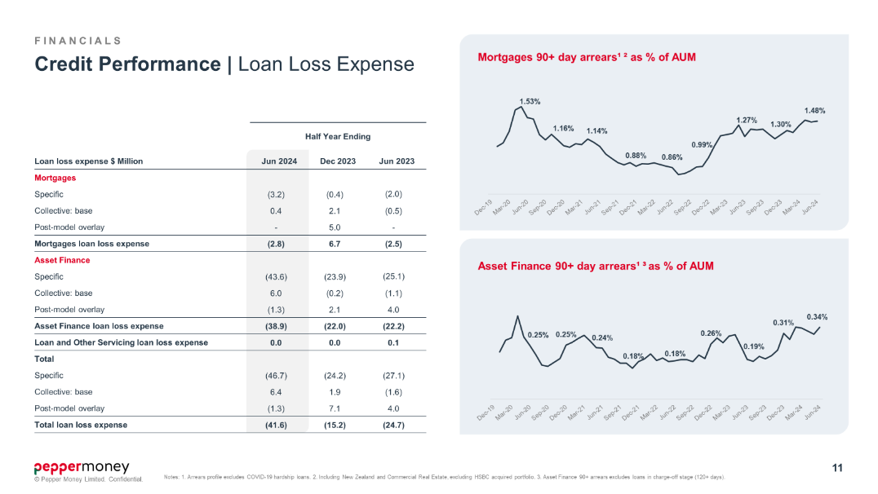

* In terms of 90+ days arrears – which is a good indicator of future losses – Mortgages closed June 2024 at 1.48% - and as you can see from the graph on the top right-hand side this remains in line with the long-term average, when the experience under COVID, is removed.
* Likewise, Asset Finance 90+ days arrears at 0.34% of AUM at June 2024 is only marginally up versus the long term pre-COVID run rate. As I mentioned, as the Origination profile for Asset Finance over the first half of 2024 was weighted to Tier A and Novated Lease customers, the overall arrears profile as we move through 2024 and into 2025 will start to rebalance.
* And again – we remain well provisioned, including holding $10 million in Post Model Overlays.
* Turning now to Expenses on slide 12.

slide number 12

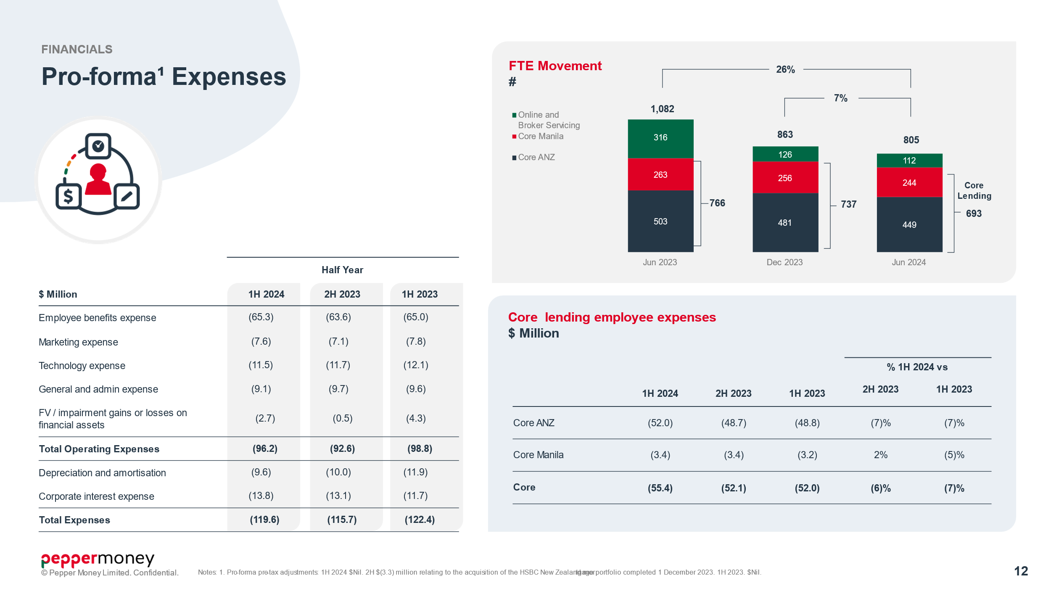

* Our constant investment in technology and process improvement, coupled with our disciplined approach to managing expenses – continues to deliver benefits.
* In the half to June 2024 Total Expenses reduced 2% on PCP.
* Scale economies through technology, automation and process improvement, allowed us to continue to reduce FTE, with Core FTE – being those who support the Lending businesses, reducing by 10% on PCP. As a result, Employee Expenses increased by less than half a percent over the same period, seeing us absorb the impact of salary and wage inflation.
* Other than Corporate Interest all other expenses reduced on PCP. Corporate Interest reflects the impact of higher BBSY versus prior comparable period.
* When compared to the second half of 2023, Total Expenses only increased by 2%, as we chose to write down the value of an equity investment held, and Corporate Interest was higher given higher BBSY. All other expense lines reduced first half 2024 over the second half 2023, including Employee expenses, as we lowered our FTE.
* Turning to our Pro-forma Income Statement on slide 19.

slide number 13

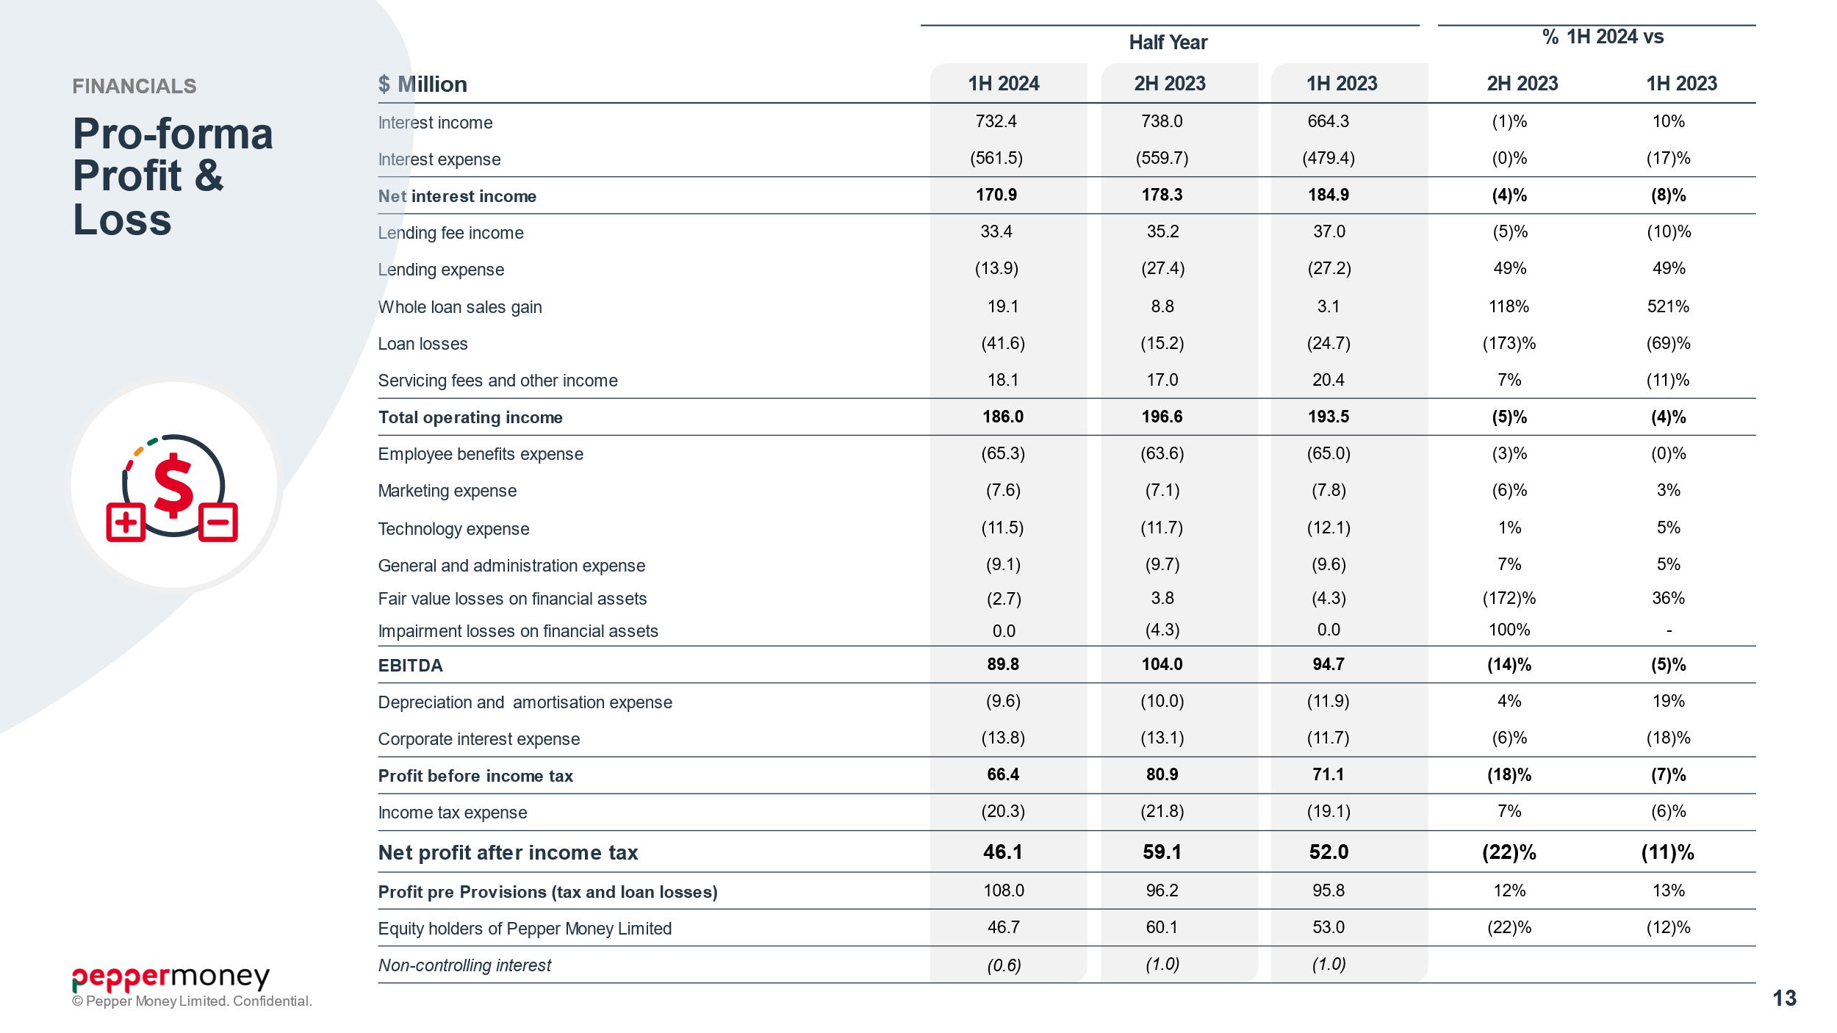

* In the first half of 2024, Total Operating Income reduced (4)% on PCP given the lower originations growth, and increased Loan Loss expense. These movements were partially offset by the gain from Whole Loan Sales executed.
* Cost management and scale economies supported the business to deliver EBITDA of $89.8 million, and Net Profit After Tax, on both a Statutory and Pro forma basis of $46.1 million.
* Profit pre-Tax and Provisions for the half at $108 million, increased 13% on PCP and 12% over the second half of 2023.

slide number 14

* Slide 14 details our Core Operating metrics, which have largely been covered so I will turn directly to cash on slide 15 and then onto the balance sheet

slide number 15

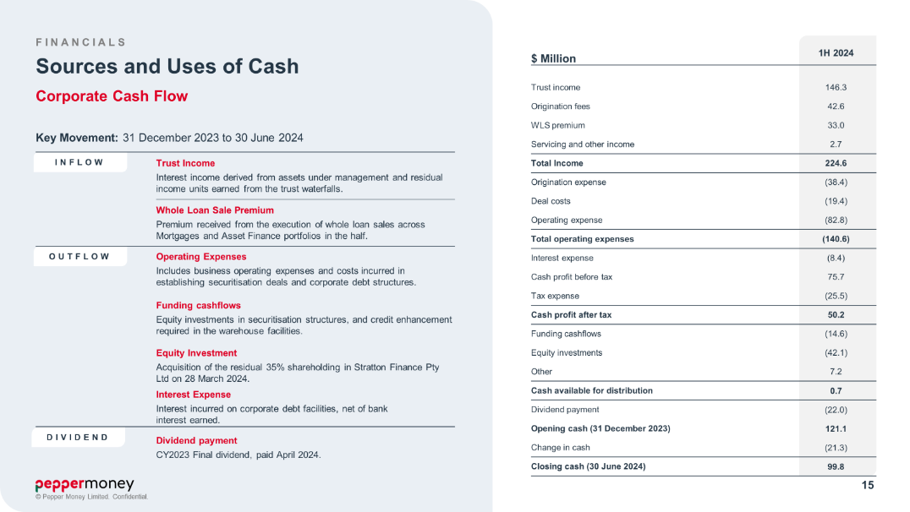

* As at June 30 2024, we had $99.8 million in unrestricted cash, compared to $78.8 million June 2023 and $121.1 million as at 31 December 2023
* We completed the acquisition of the residual 35% interest in Stratton, effective 28 March, with the $41.9 million paid funded through operating cash flows.
* Our capital management was also supported by our Whole Loan Sales strategy which delivered $33.0 million in premium over the period.
* Otherwise, cash flows were all in the normal course of business, following our origination and funding profile.
* Turning now to our Balance Sheet on slide 16.

slide number 16

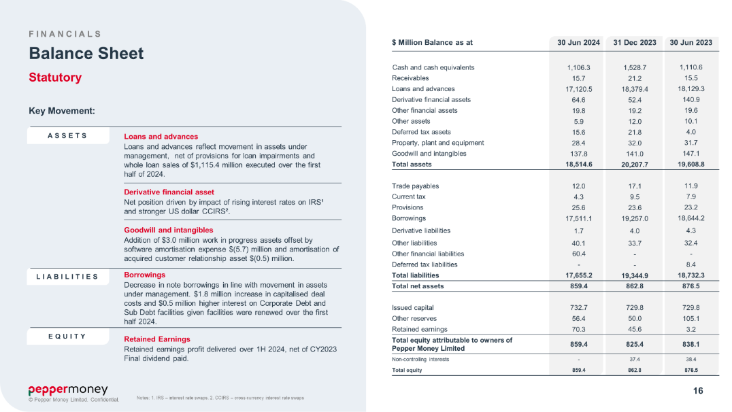

* The main movement, as you would expect, has been in Loans and Advances which, at $17.1 billion for 30 June 2024, has followed the movement in AUM, including Whole Loan Sales, net of loan loss provisions.
* We originated $3.3 billion in new financial assets over the first half of 2024 – with asset growth financed by the issuance of two Public Term securitisations of $1.4 billion, and a further $1.1 billion of Whole Loan Sales.
* As the Mortgage market remains soft, we reduced warehouse capacity to $9.2 billion over the period.
* Net Assets at 30 June 2024 at $860 million were flat on December 2023.
* Net Tangible Assets to Loans and Advances at 4.1% was up from 3.8% December 2023.
* Following the maturity, and repayment, of Pepper Money’s Corporate Debt Facility, a new syndicated 3-year revolving credit facility was established on the 23rd of May 2024. Given demand, we were able to increase the size of the facility from $200 million to $270 million. The facility, at period end, remained drawn at $155 million.
* I have already covered sources and uses of cash. We closed June 2024 with an unrestricted cash balance of $99.8 million.
* Retained earnings reflect the profit delivered by the business, net of the 2023 Final dividend paid.
* And given the strength of our capital position the Board has lifted the Interim Dividend payout ratio from 30% in 2023 to 47.5% in 2024. This will see an Interim Dividend of 5 cents per share paid on the 10th of October.
* Thank you and I will now hand back to Mario to close.

slide number 17

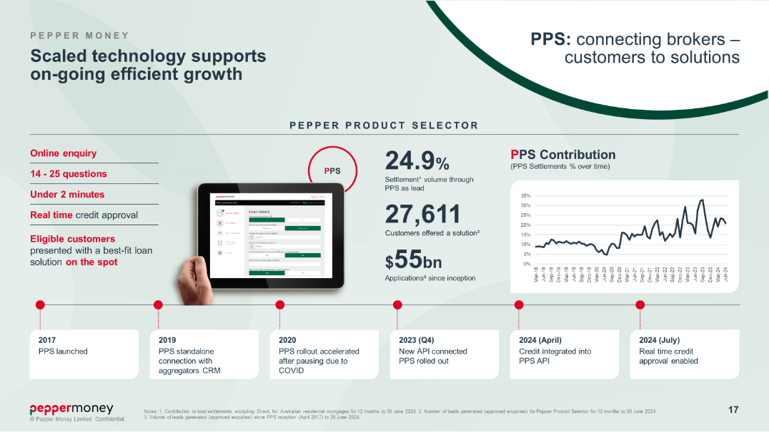

* Thanks Therese
* Before running through the Outlook and opening to questions I thought it would be worthwhile looking at how our purpose-built technology is driving scale – and how, when growth returns, we can capture it efficiently.
* Turning to slide 17
* Pepper Product Selector – or PPS - is our digital scenario assessment and approval tool designed to streamline the Mortgage process for our customers and distribution partners.
* PPS has evolved.
* PPS now provides real time credit assessment and approval.
* PPS is API integrated into aggregators CRMs. As a broker captures customer information in their CRM, PPS is seamlessly integrated providing real time credit assessment, product selection and approval.
* PPS not only saves a broker time but gives the broker confidence of both speed and probability to yes, for the customer. PPS provides customers with more choice and transparency.
* I believe the technology, and customer centric automated processes, which sit behind PPS will be the future of lending.
* Since launching in 2017, 25% of origination volumes has been generated via Pepper Product Selector. Nearly 28,000 customers have been offered a Pepper Money solution through PPS. We have generated more than $55 billion in application volume.

ss

* Since July 2024, we have been piloting “real time” PPS with a major aggregator. Over this period volumes increased 113% for them, at a time when all our other channel increased 12%.
* Plans are already in place to continue the rollout of “real time” PPS to the rest of our distribution network. This will deliver not just scale in terms of leads and approvals but continue to drive origination efficiencies.
* So how do we see the Outlook for the balance of 2024 – turning to slide 18

slide number 18

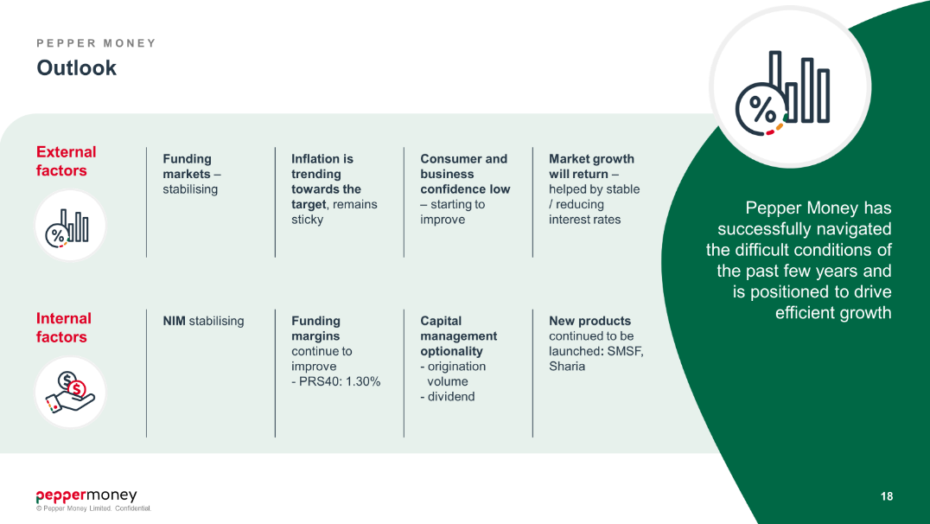

* The start of 2024 has been encouraging:
  + inflation is moderating;

and

* + the expectation of further interest rate rises has slowed.
* And our performance over the first half of 2024 has been strong with Mortgage volume increasing and total NIM expanding.
* But we cannot shy away from the fact that the macro-environment and cost of living pressures are proving challenging, and consumer and business confidence remains low.
* I am, however, encouraged by how resilient most of our customers remain.
* While unemployment remains low – which is a positive – we do need to balance this with low productivity and growth.
* But all in all, I do feel that the headwinds are easing, and as a business we feel confident as we move through 2024. We are prepared to capture more opportunities as they become available.
* Over the 24 years we have been in business we have successfully managed through all cycles. We have managed our customers through the rates rises, we have sought new opportunities, and we have launched new products such as Self-Managed Super Fund Mortgages and Sharia lending.
* Our constant investment has delivered scaled technology and processes.
* We have sufficient funding headroom available. We are positioned to capitalise on growth as it returns.
* We have built a business with strong core competencies in credit and underwriting, distribution, funding, data and technology.
* We are diversified, both in terms of the scale of our two-core lending businesses of Mortgages and Asset Finance, as well as the growth from our Loan and Other Servicing business unit which delivers a capital light annuity style income stream from our Whole Loan Sales strategy.
* We are also disciplined: whether it be how we manage credit, expenses or capital. We remain, as always, well provisioned.
* With $19 billion in Assets under Management today we are strong and have the ability to capitalise on opportunities as they emerge.
* Thank you and I will now hand back to the operator for questions.

slide number 19

